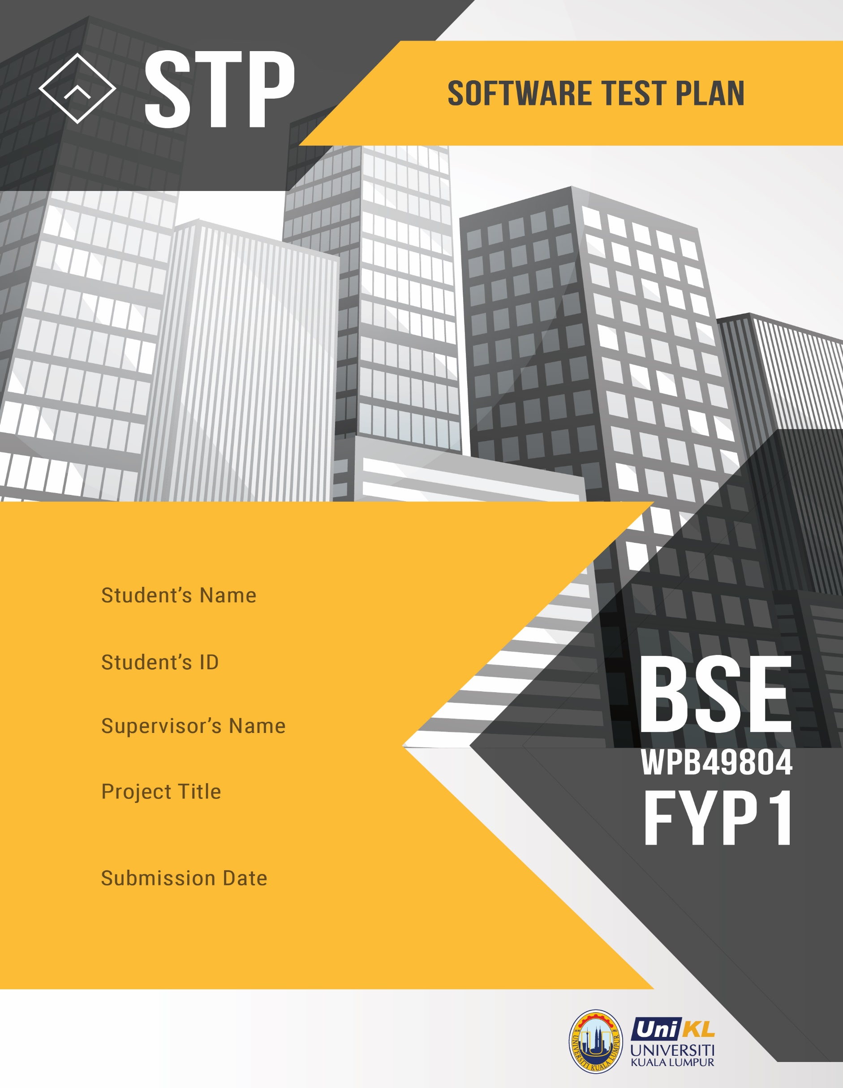

**Student Name & Student ID:**

Muhammad Faid Luqman Bin Nor Hasni (52213218086)

Faizah Chaibou Issoufou (X)

Syifa’Ul Husna Binti Halim (X)

Nik Azlina binti Nik Ahmad

521217217217217

Ms. Nik Azlina binti Nik Mahmood

**Project: Hotel Empire Online Reservation**

**Lecturer Name: Nurul Sharaz Binti Azmanuddin**

**Submission Date: 26/10/2020**

Write Your Project Title Here Write Your

Project Title Here

21 July 2019

**Document Information and Approvals**

**version history tab**

|  |  |  |  |
| --- | --- | --- | --- |
| **Version #** | **Date** | **Revised By** | **Reason for change** |
| **1.0** | **15/10/2020** | **Muhd Faid Luqman** | **Test Plan Created** |
|  |  |  |  |
|  |  |  |  |
|  |  |  |  |

document Approval Tab

|  |  |  |  |
| --- | --- | --- | --- |
| **Approver Name** | **Project Role** | **Signature/Electronic Approval** | **Date** |
| **Muhd Faid Luqman** | **Project Manager** | **MfaidLuqman** | **19/10/2020** |
|  |  |  |  |
|  |  |  |  |
|  |  |  |  |

# TABLE OF CONTENT

TABLE OF CONTENTS 3

1. TEST PLAN INTRODUCTION 11

1.1 System Overview 11

1.2 References 13

1.3 Document Overview 14

2. TEST STRATEGY 15

2.1 Test Objective 15

2.2 Scope 16

2.3 Test Items 16

2.4 Test Process 16

2.5 Item Pass/Fail Criteria 19

2.6 Entry and Exit Criteria 20

2.7 Risks and Contigencies 21

2.8 Test Level 22

2.8.1 Black Box Testing 22

2.8.1.1 Use Case Testing 23

3. TEST CASE SPECIFICATION 27

4. TEST ENVIRONMENT 30

4.1 Facilities required 30

4.2 Required resources 30

4.3 Training 32

4.4 Test Team Composition 33

5. TEST SCHEDULE 35

6. DEFINITIONS, ACRONYMS AND ABBREVIATION 38

7. APPENDIX 39

1. **TEST PLAN INTRODUCTION**

The document outlines an Acceptance Test Plan in order to test the Hotel Empire website.

* 1. **Purpose**

The purpose of this document is to outlines the Acceptance Test Plan in order to test the developed Hotel Empire website. Certainly to ensure that the software delivers what client expected based on the defined requirements that have been provided. In addition to that, the plan is practical in order to guarantee the standard compliance and regulation. The ATP will be used by the test team in order to plan, conduct and document the acceptance testing.

* 1. **System Description**

The Empire Hotel website provides various modules that are intended to aid our client needs. The most important part is the website able to widen and reached out more Hotel Empire target audience. Enhance the current business model by providing online capabilities. The website allows the Empire Hotel customer to browse on available hotel room and its rates, gallery and the hotel information. In addition, they can make an online room reservation with in-built payments method. The customer can also check on their past reserve history which can be helpful as insight.

Meanwhile for the Hotel admin, they can check for any reservation made for that day on their homepage dashboard which make it easier to keep track of today reservation. Not only that, the admin can examine any new fresh input of reservation from customer that just recently booked their rooms. Then, they can even update the status of that reservation whether to confirm, complete or cancel booking. On top of that, the website offers searching capability in which the reservation booking can be traced via booking ID. Moreover, the admin can manage the website gallery easily where they can upload new or updated images. Next, a manage room capability is available so the admin can add more, update or remove types of room. Last but not least, the website allow admin to manage the bank option where it can be added, updated and remove when preferred.

* 1. **References**

|  |  |
| --- | --- |
| **IEEE Standard 829-1983** | IEEE Standard for Software Test Plan. |
| **Empire Hotel Change Requests Document** | A document that consist of all 16 change request forms available. |
| **ISTQB Slides** | Numerous slides from chapter 1 until 7 are used as references. Obtained from Software Testing class. |
| **Hotel Empire SCM Plan** | It a good reference document that can give great insights on the process of change and control CIs. |

Table 1: List of refer documents

* 1. **Document Overview**

The STP document consists of six section as brief below:

* **Section 1** explains **Test Plan** **Introduction** introduce the current acceptance test plan and its system description, references and document structure overview.
* **Section 2** contains **Test Strategy** describes the testing strategy that includes test objective, test scope, test process, item pass/fail criteria, test level, entry and exit criteria.
* **Section 3** contains **Test Case Specification** outline the current test cases in development along with Use Case Diagram.
* **Section 5** contains **Test Environment** defines required facilities, hardware, software and other necessary requirement in order for test to be executed smoothly.
* **Section 6** contains **Test Schedule**, discuss on overall schedule plan including testing activities.

1. **TEST STRATEGY**

A test strategy is an outline what the method and way to do testing for this Empire Hotel software development life cycle. It is the main core part of this test plan.

* 1. **Test Objective**

The main objective for this test plan is

* To remove the bugs as many as possible to gain system robustness.
* Ensure that the software is certified to be released into real environment.
* To gain high confidence that all of the functionalities of Empire Hotel are workable as expected.
* To acquired sign-offs from all important Empire Hotel stakeholders.

* 1. **Scope**

The scope of this Acceptance test plan is to ensure that all of the requirements defined in Approved Change Requests form are met and tested accurately.

* 1. **Test Items**

The item to be tested is Empire Hotel website prototype

* + 1. **Features Tested**

Below is the list of features that will be tested.

|  |  |  |
| --- | --- | --- |
| Empire Hotel Website | | |
| ID | Features | Priority |
| CR1 | New Website Design with Minimalist Concept | 5 |
| CR2 | Updated Navigation Bar for Login and Register | 5 |
| CR3 | New bank type option (Bank Islam & Ambank) | 3 |
| CR4 | New Message Box for Additional Info | 4 |
| CR5 | Refine Payment Approach | 4 |
| CR6 | Solve Print Button | 5 |
| CR7 | New Validation for Reservation | 3 |
| CR8 | New Login for Customer | 5 |
| CR9 | New Register for Customer | 4 |
| CR10 | New Logout for Customer | 3 |
| CR11 | New Reserve History | 5 |
| CR12 | New Status Confirmation  (Cancel, Confirm & Complete Booking) | 3 |
| CR13 | New Room Cancellation for Customer side | 3 |
| CR14 | New Searching Capability for Admin | 5 |
| CR15 | New Manage Bank for Admin | 4 |
| CR16 | New Validation for Login and Register | 3 |

* 1. **Test Process**

This is the overall test process that will be applied in Empire Hotel project testing.

1. **Test Planning**

**Analyze Existing Documents (Test Basis)** which is Change Requests document as it includes the changes information and its requirements. Then, **create Software Test Plan** which contains the test objective, test scope, test strategy, test case specification, test schedule, test environment and resources. Next, **review all the test components** to ensure completeness, clarity and accuracy.

1. **Test Preparation**

Prepare the test environment by assembling the necessary facilities, resources and tools that has been outlined in STP to conduct fulfilling testing with complete precondition criteria. Ensure requirements are testability

1. **Test Execution**

Execute the test cases and its test procedures in which it compares the obtained test results with the expected actual test results to determine if test passed or failed**.** Lastly, track and record all of the actions taken, results and incident for the next further stage which is review.

1. **Test Result Reviews**

Itis done to analyze the open incidents so that we can know the severity. To do this, it compar the acquired test results with the expected test result. Then alert to developers and Empire hotel stakeholders regarding the incidents. Defects may need to be fixed and retest or if relevant stakeholders agree then test can be closed with the following defects (although it usually a minor one).

1. **Test Closure**

It is used to evaluate the exit criteria which consist of activities such as checking whether deliverables delivered or not, incident and defects has been solved and all test cases have been executed or not. If done, then it will close incident report, archive testware and its related matter. Lastly determine how the testing and what can be improvised.

* 1. **Item Pass/Fail Criteria**

The criteria to determine test pass or fail is through the approved change requests in which we evaluate whether the requirements that based on the CRs meet and tally or not. If it meets with what have been specified exact in the approved Change Request form, then pass is obtained. If did not meet what have been defined in the change request, then it be deliberated as fail thus a rework or revision may require to solve the existing problems or incident.

* 1. **Entry and Exit Criteria**

Entry and exit criteria define when testing activities started and when to stop it. This is essential and required to be mentioned in test plan as exhaustive testing is impossible.

* + 1. Entrance Criteria

Below are the criteria required to start testing

* The change request has been reviewed and approved by relevant stakeholders.
* The change request has been implemented and is ready for testing
* The change request and its requirements are testable
* Test environment have been prepared and setup
  + 1. Exit Criteria

Below are the criteria required to stop the testing activities as a whole

* All test cases have been tested and executed successfully
* All unresolved defects are documented
* All open major defects have been fixed, retested and met the requirements
  1. **Risks and Contingencies**

In every project, risks are available and shall need to be addressed by providing contingencies plan. Below are several major risk that need to have contingencies.

|  |  |  |  |
| --- | --- | --- | --- |
| **ID No** | **Project Risks** | **Impact** | **Contingencies** |
| 1 | Unprepared Test Environment | Unable to run the test | Proper planning must be done and followed strictly. If event has occurred, then increase labor power and quickly prepared the test environment. |
| 2 | Unavailability of Test data | Test delay  Also, May cause test inaccuracy | Conduct test on past experience basis. Also ask the Empire Hotel stakeholders on what kind of data that they want to put in the website for selected part. |
| 3 | A lot of defects found | Unable to run all of the test case | Fix the defects first one by one before start to test again. |

Table 3: Project Risks

* 1. **Test Level**
     1. **Black box Testing** 
        1. **Use Case Testing**

[Faizah Fill]

1. **TEST CASE SPECIFICATION**

[Faizah Fill]

1. **TEST ENVIRONMENT**

This section define necessary resources to be used as part of the test environment for testing. Test environment consist of hardware, software, facilities, training and others.

* 1. **Facilities**

The testing will be conducted at developer site; the environment is being setup in a way that it depicts similar resemblance of Empire Hotel environment. The pure reason not to conduct at client environment is due to how it is still not in controlled environment and still not ready for the client to test. Moreover, it easier for the developer to fix quickly. The test environment facilities shall have a physical room space with chairs, tables and plug points nearby. Electrical and internet connection resource shall be available.

* 1. **Required resources (hardware/software)**

[Syifa fill]

* 1. **Training**

A training can be time consuming but can be necessary to ensure that the tester really aware, experience and knowledgeable in testing aspects and its mechanism. This is important to ensure accurate, productive and efficient testing. On top of that, to ensure that they also know the business process of Empire Hotel and how the website supposed to work based on this business process.

* 1. **Test Team composition**

**Test Planner / Controller – Muhammad Faid Luqman Bin Nor Hasni**

* Produce and lead the test plan
* Ensure it is delivered as expected in schedule and quality
* Report test progress at meetings
* Co-ordinate review and signoff
* Approved or reject test contents made from other members
* Manage individual test cycles and resolve tester queries/problems.

**Lead Tester – Syifa’Ul Husna Binti Halim**

* Execute test conditions and mark-off results
* Prepare software error reports
* Ensure test systems outages/problems are reported immediately & followed up.
* Ensure entrance criteria are achieved prior to system test start.
* Ensure exit criteria are achieved prior to system test signoff.

**Test Designer – Faizah Chaibou Issoufou**

* Plan and design the test strategy in term of test level, test technique and type of test.
* Design test components such as test case and test data
* Determine appropriate techniques, tools and guidelines to implement test

1. **TEST SCHEDULE**

[Syifa Fill]

1. **Glossary**

|  |  |
| --- | --- |
| **Definition Term** | **Definition** |
| Defect | Non-conformance to requirements or functional / program specification |
| Functional Testing | Testing the features and operational behavior of a product to ensure they correspond to its specifications |
| Coding | The generation of source code. |
| Test Item | The individual element to be tested. There usually is one test object and many test items. See also test object |
| Tester | A technically skilled professional who is involved in the testing of a component or system. |

|  |  |
| --- | --- |
| **Abbreviations** | |
| STP | Software Test Plan |
| SRS | Software Requirement Specification |
| IEEE | Institute of Electrical and Electronics Engineers |
| ISO | International Organization for Standardization |
| ISTQB | International Software Testing Qualifications Board |
| CR | Change Request |
| SCM | Software Configuration Management |

1. **APPENDIX**